**CHECKMATE FUNCTION**

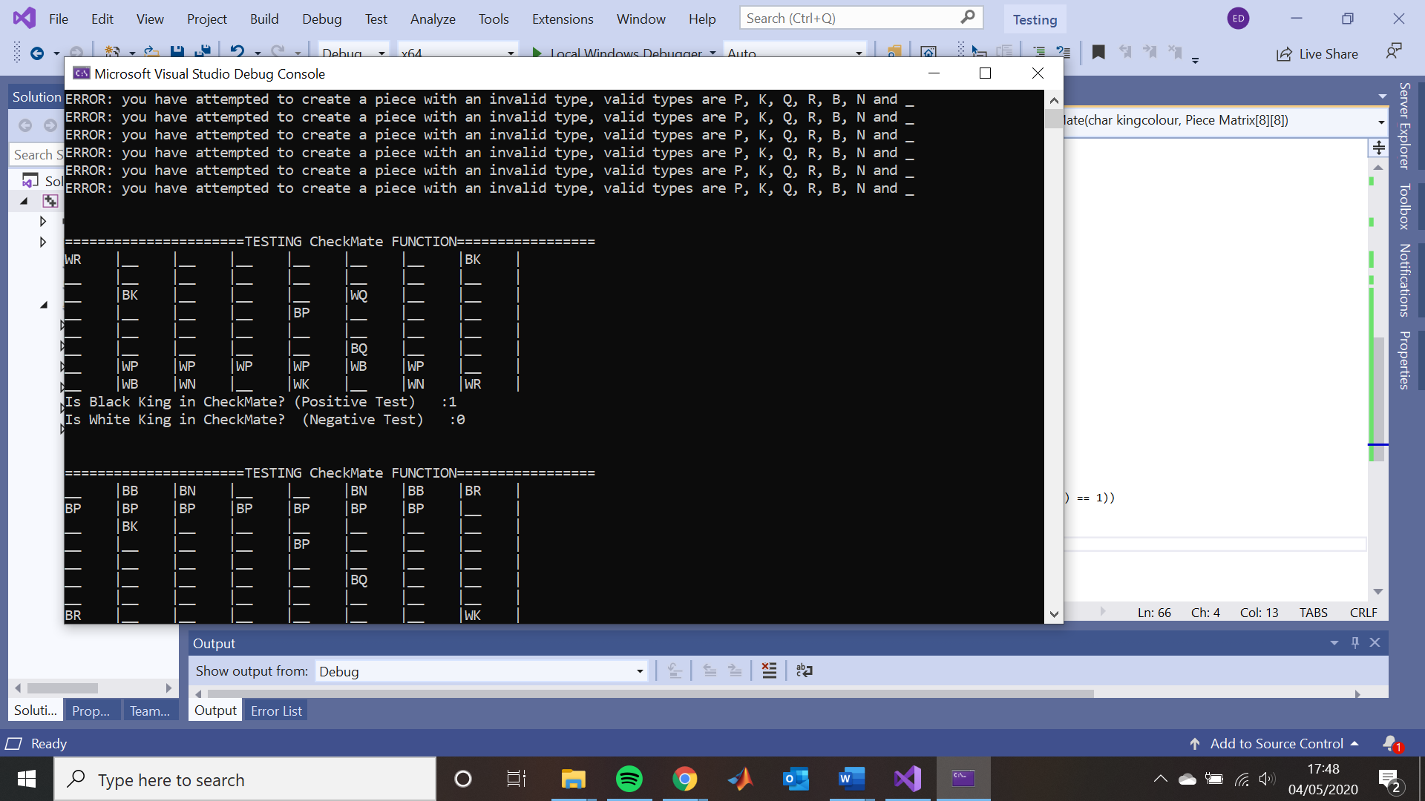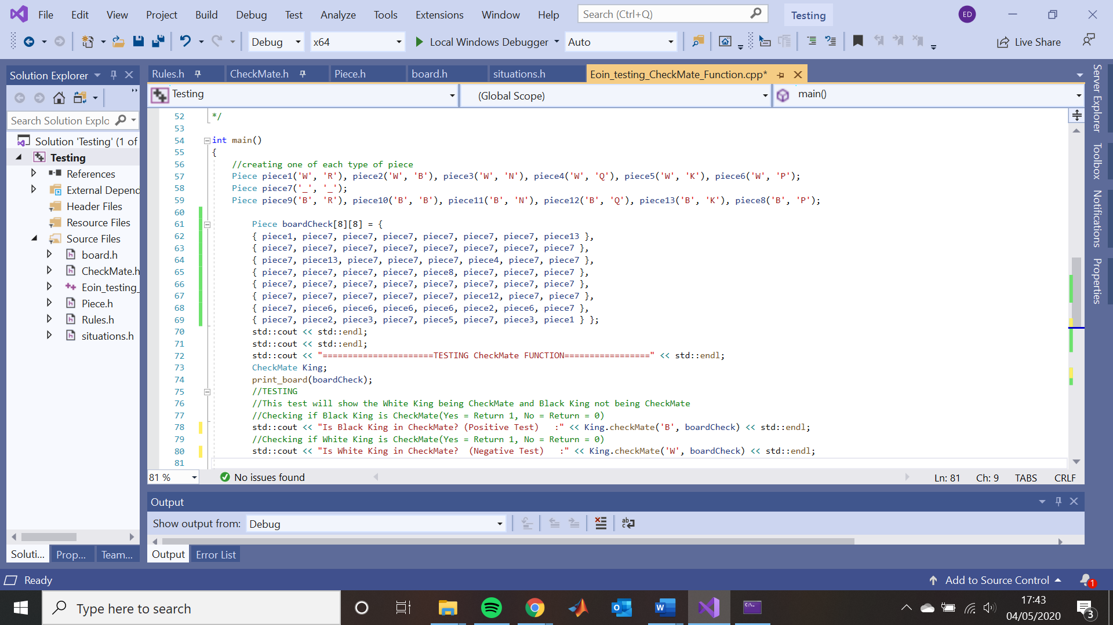BLACK KING in CHECKMATE

The above tests the Checkmate function for whether Black King and White King is in Checkmate. In the above test it shows that Black King is indeed in checkmate and thus should be game over. It also shows that the White King is not in Checkmate.

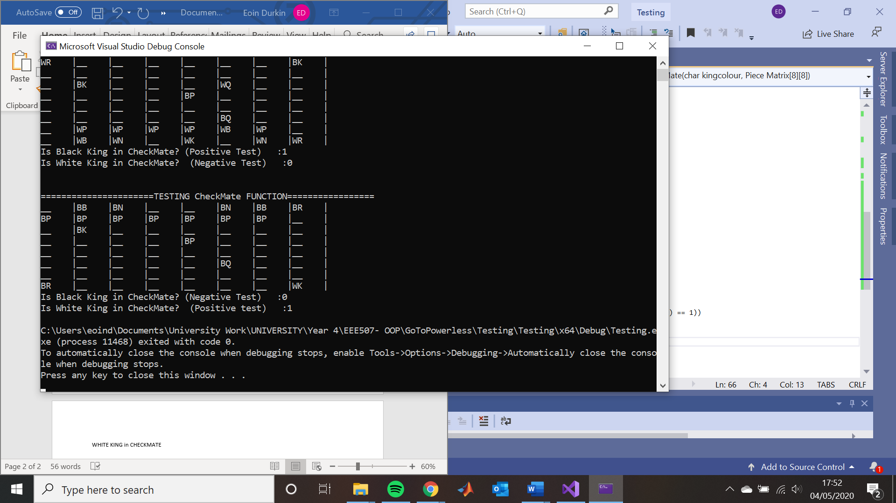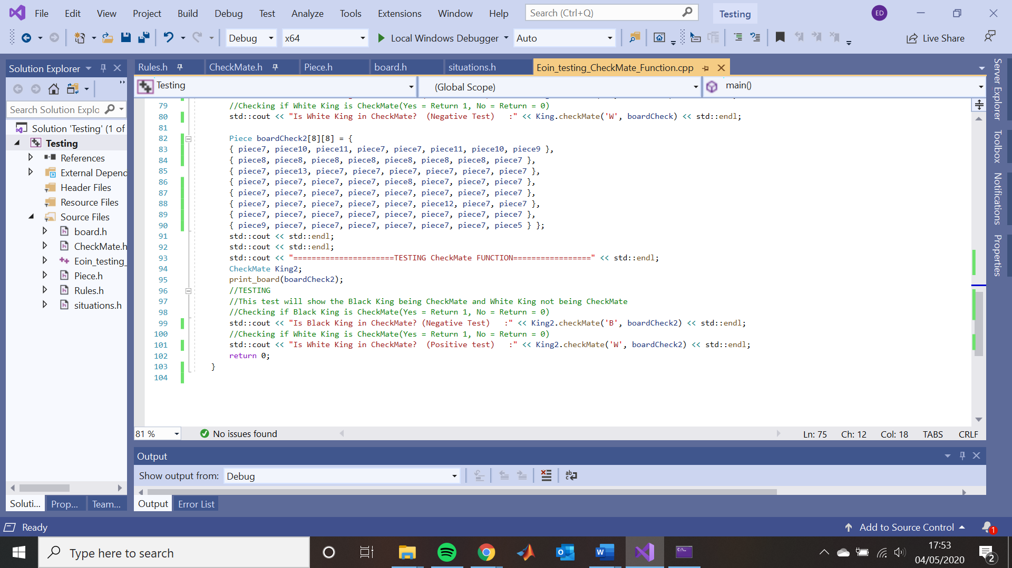WHITE KING in CHECKMATE

This above code now tests the Checkmate function for the White King, it shows that indeed the White King is in checkmate this time and thus returns a 1, it also shows that the Black king is not in checkmate as it returned a 0